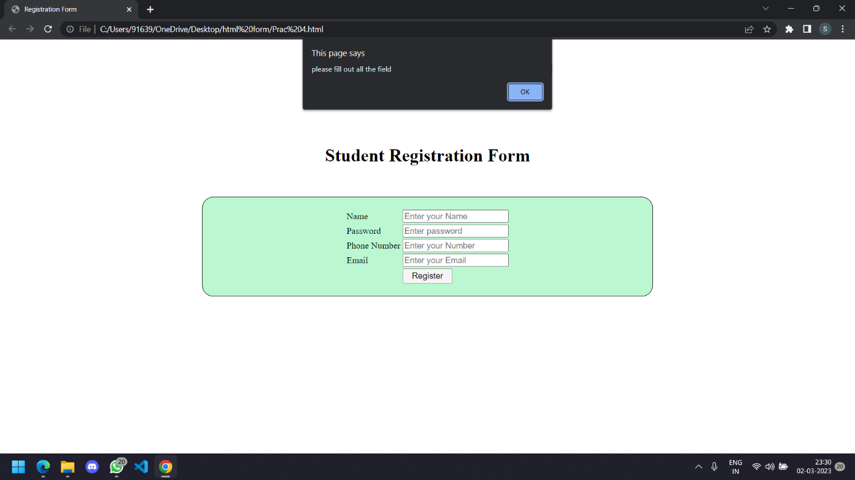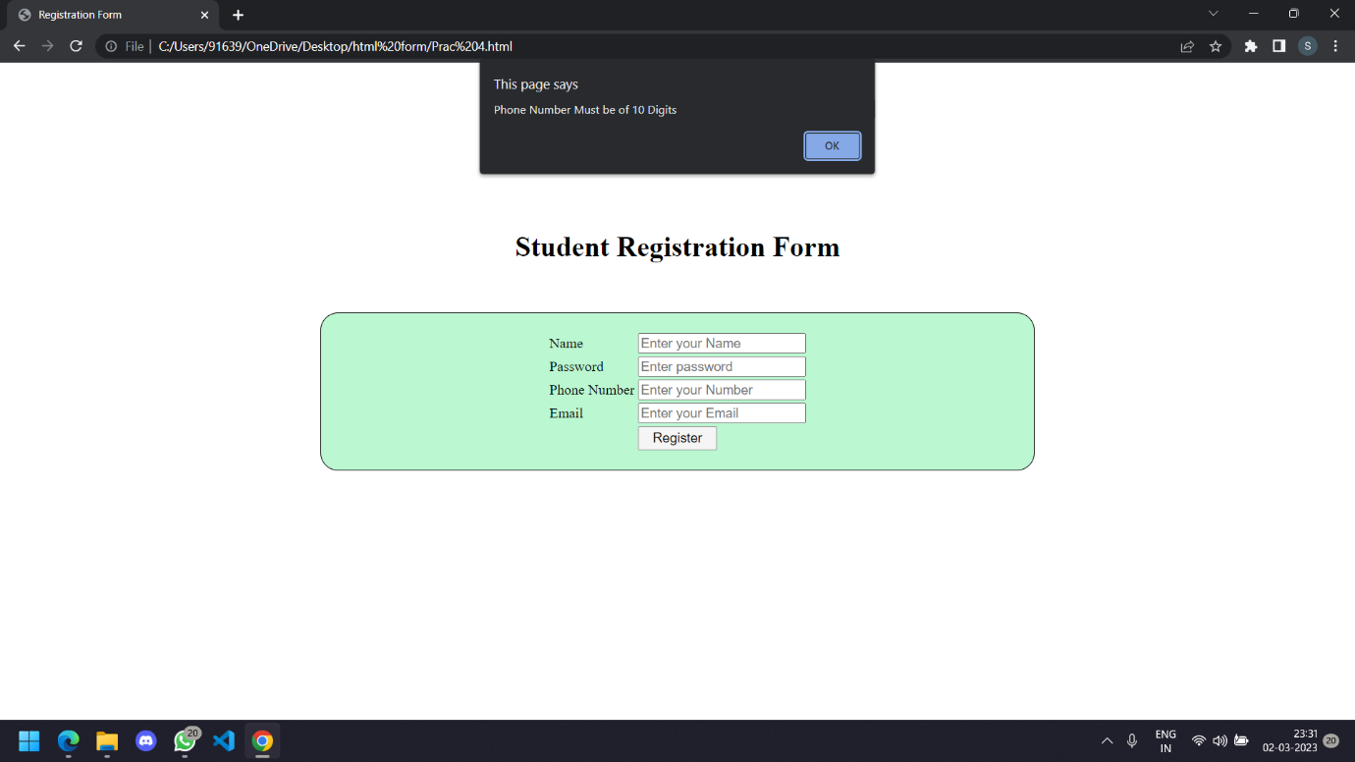

Sinhgad Academy Of Engineering

Name :- Subrat Dhapola, Roll No.:- COTA36

Class:- T.E, Div:- A, Sub:- Web Technology

